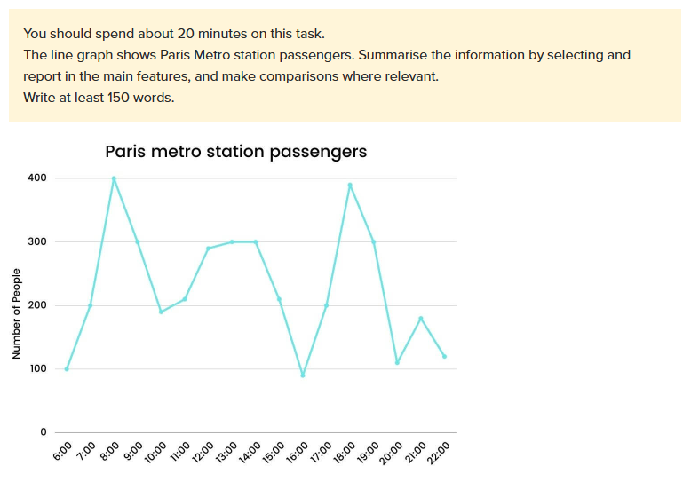

The line graph shares insight into the number of people using a metro station in Paris during the day.

Overall, the graph shows that the most crowded period is in early morning and evening.

Looking to the graph, the most time that people using metro station is in the morning period. There is a dramatic increase between 6:00 am to 8:00 am, from 100 passengers to 400 passengers, but sharp reduction to 200 passengers within the duration of two hours.

Between 11:00 am to 2:00 pm, the number of people using metro system stays stable, at approximately 300 passengers. In the afternoon, there was a decline in the number of passengers to almost 100 at 4:00 pm. The evening soars from 100 passengers to approximately 400 passengers. The number of people using metro station decreases gradually to 100 passengers. After a small rise at 9:00 pm to 180 passengers, the number decline over 100 passengers at 10:00 pm.